Lab 2: Network Commands for Testing and Troubleshooting
Required Tools
- A computer with command line interface (CLI) access
- Network connection (wired or wireless)
Objective
To familiarize with essential network commands used for testing and troubleshooting network connectivity issues.
Theory
Introduction to Network Troubleshooting
Network troubleshooting is a systematic approach to identifying and resolving connectivity issues in computer networks. Command-line tools provide network administrators with powerful utilities to analyze network behavior, test connectivity, and diagnose problems efficiently.
The OSI Model and Network Commands
Network commands operate at different layers of the OSI model. Commands like ping and tracert work at the Network Layer (Layer 3) for testing connectivity and routing. The arp command operates at the Data Link Layer (Layer 2) for MAC address resolution, while netstat monitors Transport Layer (Layer 4) connections. Application layer tools like nslookup help diagnose DNS issues.
Key Networking Concepts
TCP/IP Protocol: The fundamental communication protocol suite for networks. IP handles addressing and routing, while TCP ensures reliable data delivery.
DNS (Domain Name System): Translates human-readable domain names into IP addresses that computers use for communication.
ARP (Address Resolution Protocol): Maps IP addresses to physical MAC addresses on local networks.
Routing: The process of selecting network paths to send data packets. Routing tables determine the best path for packet forwarding.
Network Troubleshooting Methodology
- Identify the problem and gather information
- Test connectivity using diagnostic commands
- Analyze command outputs to isolate the issue
- Implement corrective measures
- Verify that the problem is resolved

Procedure
- Open the command line interface (CLI) on your computer:
  - Windows: Press Win + R, type cmd, and press Enter
  - Linux/Mac: Open Terminal application
- Use the ipconfig or ifconfig command to check your current network configuration
- Execute each command listed above following the provided syntax
- Document the output of each command by taking screenshots
- Analyze the results to understand your network configuration and connectivity

Network Commands: Syntax, Usage and Output:
1. ping
Syntax: ping [hostname or IP address]
Usage: Tests the reachability of a host on an IP network and measures the round-trip time for messages sent from the originating host to a destination computer.
Theory: Sends ICMP Echo Request packets to the target and waits for replies. Reports packet loss and response times to verify basic connectivity.
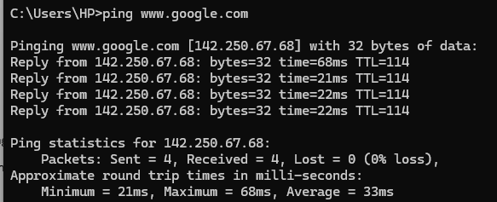

2. ipconfig
Syntax: ipconfig
Usage: Displays all current TCP/IP network configuration values and refreshes DHCP and DNS settings.
Theory: Shows network adapter information including IP address, subnet mask, default gateway, and DNS servers. First command used when troubleshooting network issues.
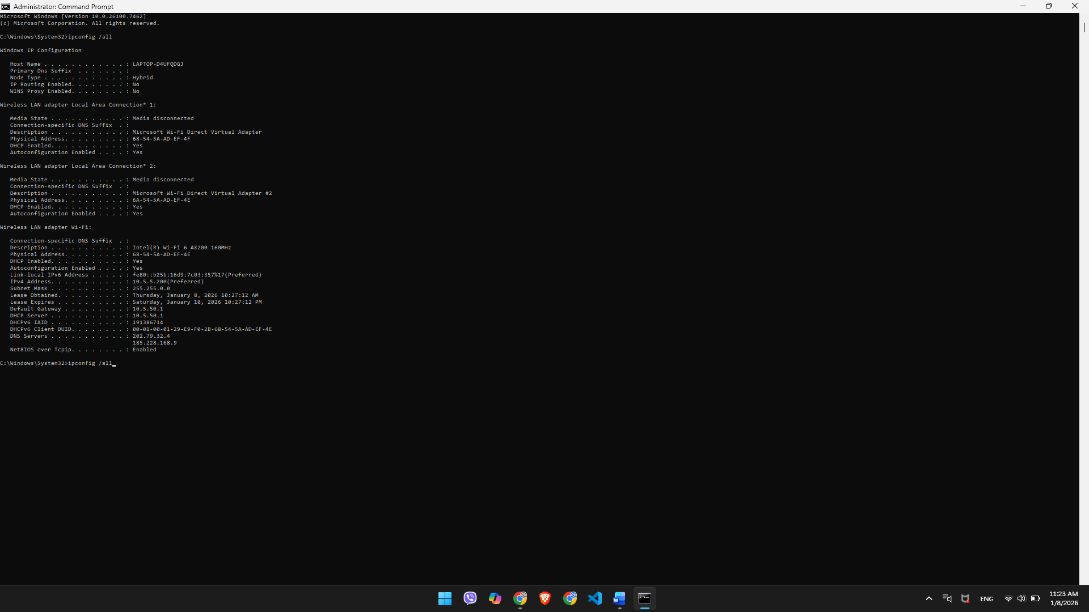

3. tracert
Syntax: tracert [hostname or IP address]
Usage: Determines the route taken by packets to reach a specific host by listing all the intermediate routers.
Theory: Sends packets with increasing TTL values. Each router along the path returns its IP address, mapping the complete route from source to destination.
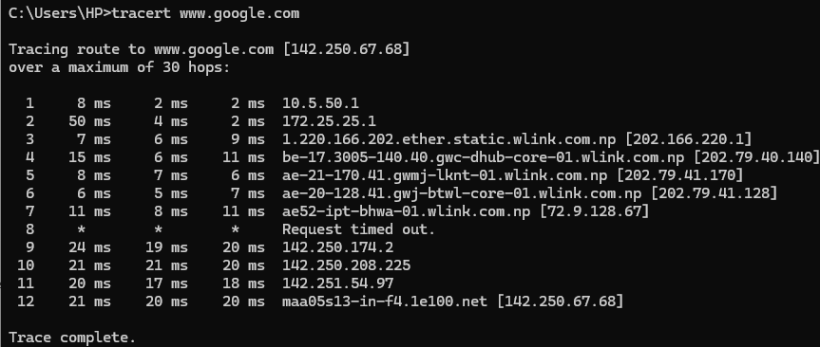

4. netstat
Syntax: netstat -a
Usage: Displays active TCP connections, ports on which the computer is listening, Ethernet statistics, and more.
Theory: Provides visibility into network connections, identifies which applications are using network resources, and verifies that services are listening on correct ports.
Common options:
- netstat -a - All connections and listening ports
- netstat -n - Numerical addresses and ports
- netstat -o - Shows process ID (PID)
- netstat -r - Displays routing table
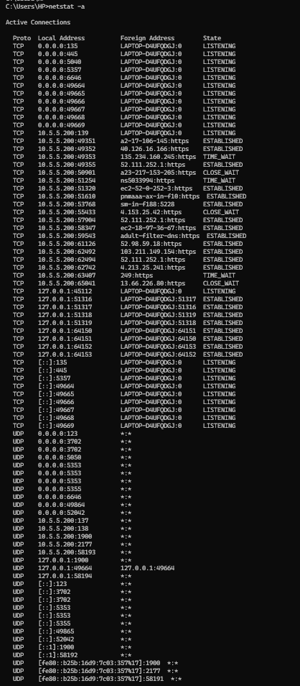

5. nslookup
Syntax: nslookup [hostname]
Usage: Queries the Domain Name System (DNS) to obtain domain name or IP address mapping information.
Theory: Performs DNS queries to resolve hostnames to IP addresses. Essential for diagnosing DNS-related problems.
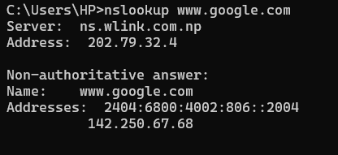

6. arp
Syntax: arp -a
Usage: Displays and modifies the IP-to-Physical (MAC) address translation table used by the Address Resolution Protocol (ARP).
Theory: Shows IP-to-MAC address mappings for devices on the local network. Helps troubleshoot layer 2 connectivity issues.
Common options:
- arp -a - Displays ARP cache
- arp -d - Deletes an entry
- arp -s - Adds a static entry
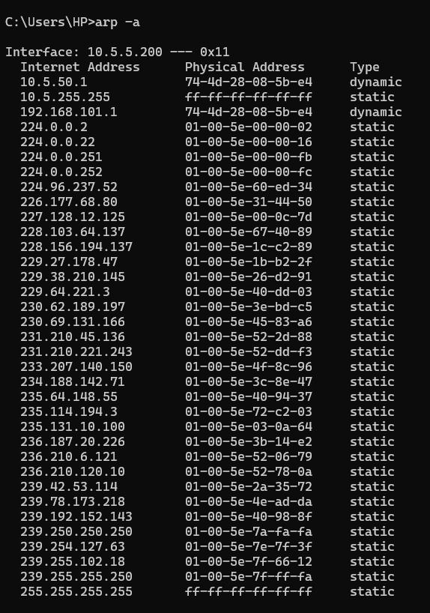

7. telnet
Syntax: telnet [hostname or IP address] [port]
Usage: Connects to a remote host using the Telnet protocol, useful for testing connectivity to specific ports.
Theory: Tests whether specific TCP ports are open and accepting connections, verifying service accessibility.
Note: No output due to installation issue.

8. netsh wlan
Syntax: netsh wlan show profiles
Usage: Manages wireless network profiles and connections on Windows systems.
Theory: Provides information about saved Wi-Fi networks, security settings, and connection status for troubleshooting wireless connectivity.
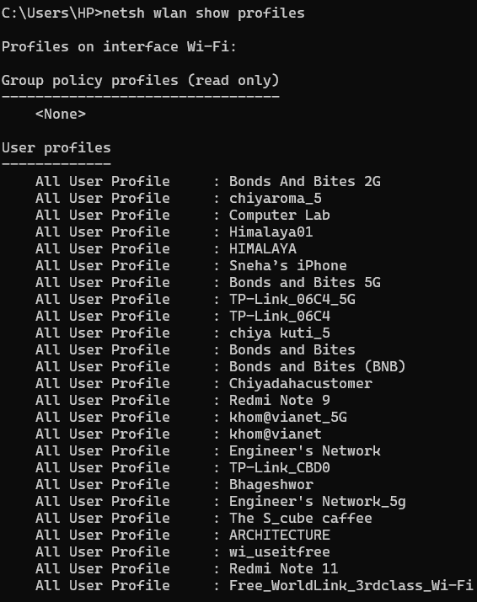

9. pathping
Syntax: pathping [hostname or IP address]
Usage: Combines the functionality of ping and tracert to provide information about network latency and packet loss at each hop.
Theory: Traces the route and sends multiple packets to each router over time, calculating statistics to identify which hops cause latency or packet loss.
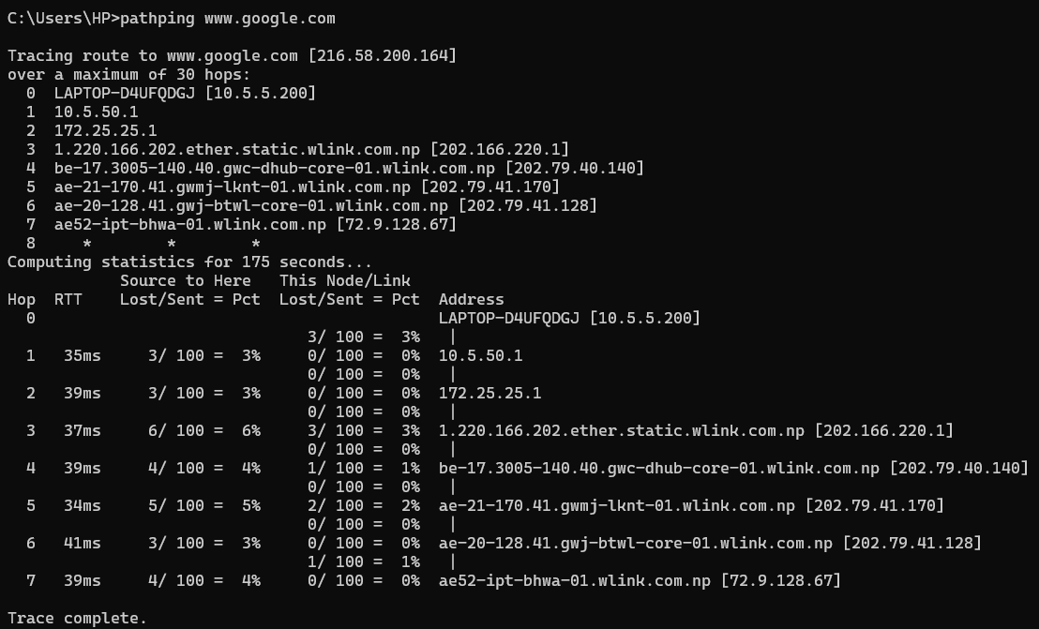

10. route print
Syntax: route print
Usage: Displays the current IP routing table on the local machine.
Theory: Shows how packets are forwarded to different networks. Each entry specifies destination, gateway, interface, and metric.

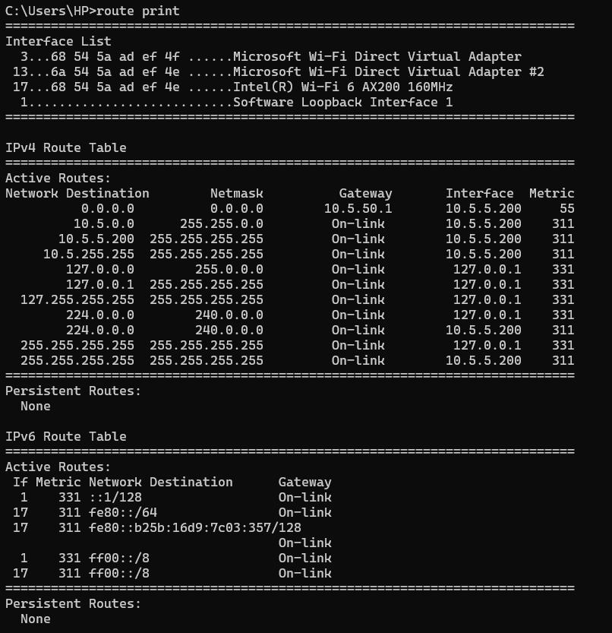
11. getmac
Syntax: getmac
Usage: Displays the MAC addresses for network adapters on the local machine.
Theory: MAC addresses are unique hardware identifiers for network interface cards. Useful for identifying adapters and troubleshooting MAC filtering issues.
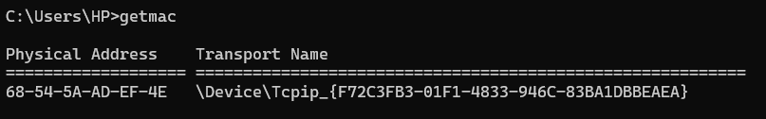

12. nbtstat
Syntax: nbtstat -a [hostname]
Usage: Displays NetBIOS over TCP/IP statistics, including the NetBIOS name table of a remote computer.
Theory: NetBIOS is a legacy protocol used for Windows file sharing and networking. Helps troubleshoot Windows networking issues.
Common options:
- nbtstat -a [hostname] - NetBIOS name table by hostname
- nbtstat -A [IP] - NetBIOS name table by IP
- nbtstat -c - NetBIOS name cache
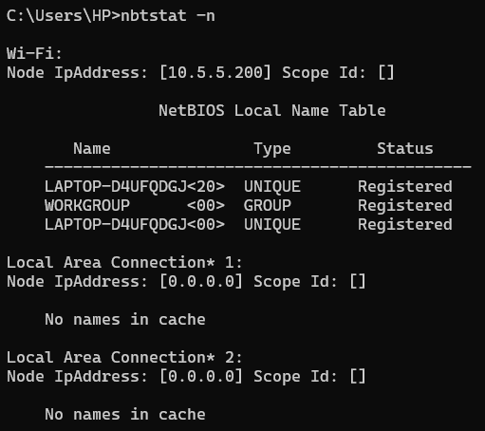

13. whois
Syntax: whois [domain name]
Usage: Retrieves registration information about a domain name from the WHOIS database.
Theory: Provides domain registration details including registrar, registration dates, and nameservers for verifying domain ownership.
Note: Some outputs were not displayed due to recognition error.
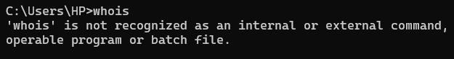

Conclusion
This lab offered a practical experience on the use of different network commands that are critical in diagnosing and troubleshooting networking problems. We got a practical experience on how to ensure network configuration, test connectivity, trace network paths, monitor active connections, and solve DNS queries, through the practical work of these tools.

